11. Create a simple cloud software application for online super market using
any Cloud Service Provider to demonstrate SaaS with the template of
customer name, address, phone, email, items, quantity etc. with the item
classification form.
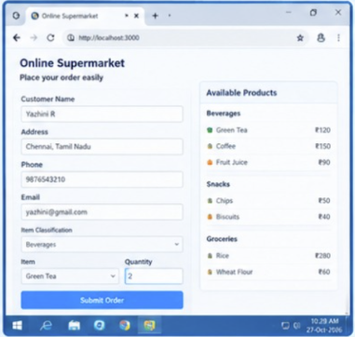
12. Demonstrate virtualization by Installing Type-2 Hypervisor in your device,
create and configure VM image with a Host Operating system (Either
Windows/Linux).
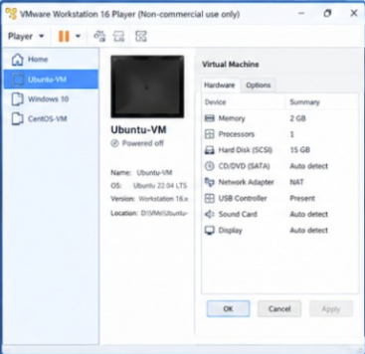
13. Create a Virtual Machine with 1 CPU, 2GB RAM and 15GB storage disk
using a Type 2 Virtualization Software.
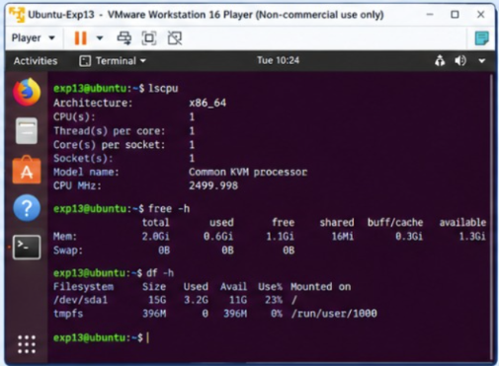
14. Create a Virtual Hard Disk and allocate the storage using VM ware
Workstation
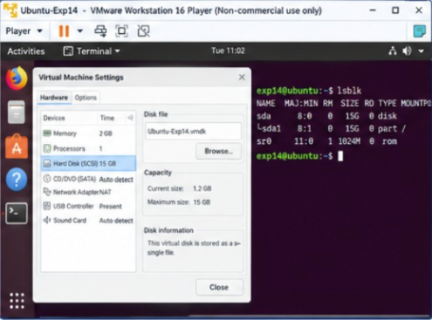

15. Create a Snapshot of a VM and Test it by loading the Previous
Version/Cloned VM
